**How to read a Gauger Cobbs Middle School Schedule:**

(Classes meet in this order)(M1 and M2)

Block-1

Block - (Advisory)

Block -2

Block 3

Block 4

(“A”-Blue Day classes meet)-A, C, E

(“B”Gold Day Classes meet)-B, D, F

ABCDEF-meetings every day.

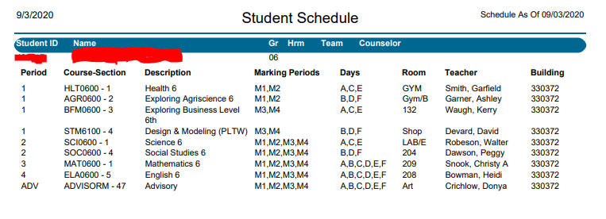In the above schedule you will notice that there are days that are labeled, ABCDEF, ACE and BDF. If the class has ABCDEF, it meets every day, if the class is ACE, the class is a Blue day only class. If the class is BDF, the class is a Gold day only class. The four core classes, Math, ELA, Science and Social Studies meet all year long, electives generally meet for a semester.